**11.1 Lipid Digestion and Absorption**

Digestion

1. Mechanical digestion (mouth and stomach)
2. Chemical digestion (small intestine)
   1. Facilitated by bile, pancreatic lipase, colipase, and cholesterol esterase

Micelle Formation

* Digested lipids may form micelles or be absorbed directly
* Micelle = water-soluble sphere with lipid-soluble interior

Absorption

1. Short-chain fatty acids
   1. Absorbed across the intestine into the blood
2. Long-chain fatty acids
   1. Absorbed as micelles and assembled into chylomicrons for release into the lymphatic system
   2. Chylomicrons leave the intestine via lacteals (the vessels of the lymphatic system) and re-enter the bloodstream via the thoracic duct (a long lymphatic vessel that empties into the left subclavian vein at the base of the neck)

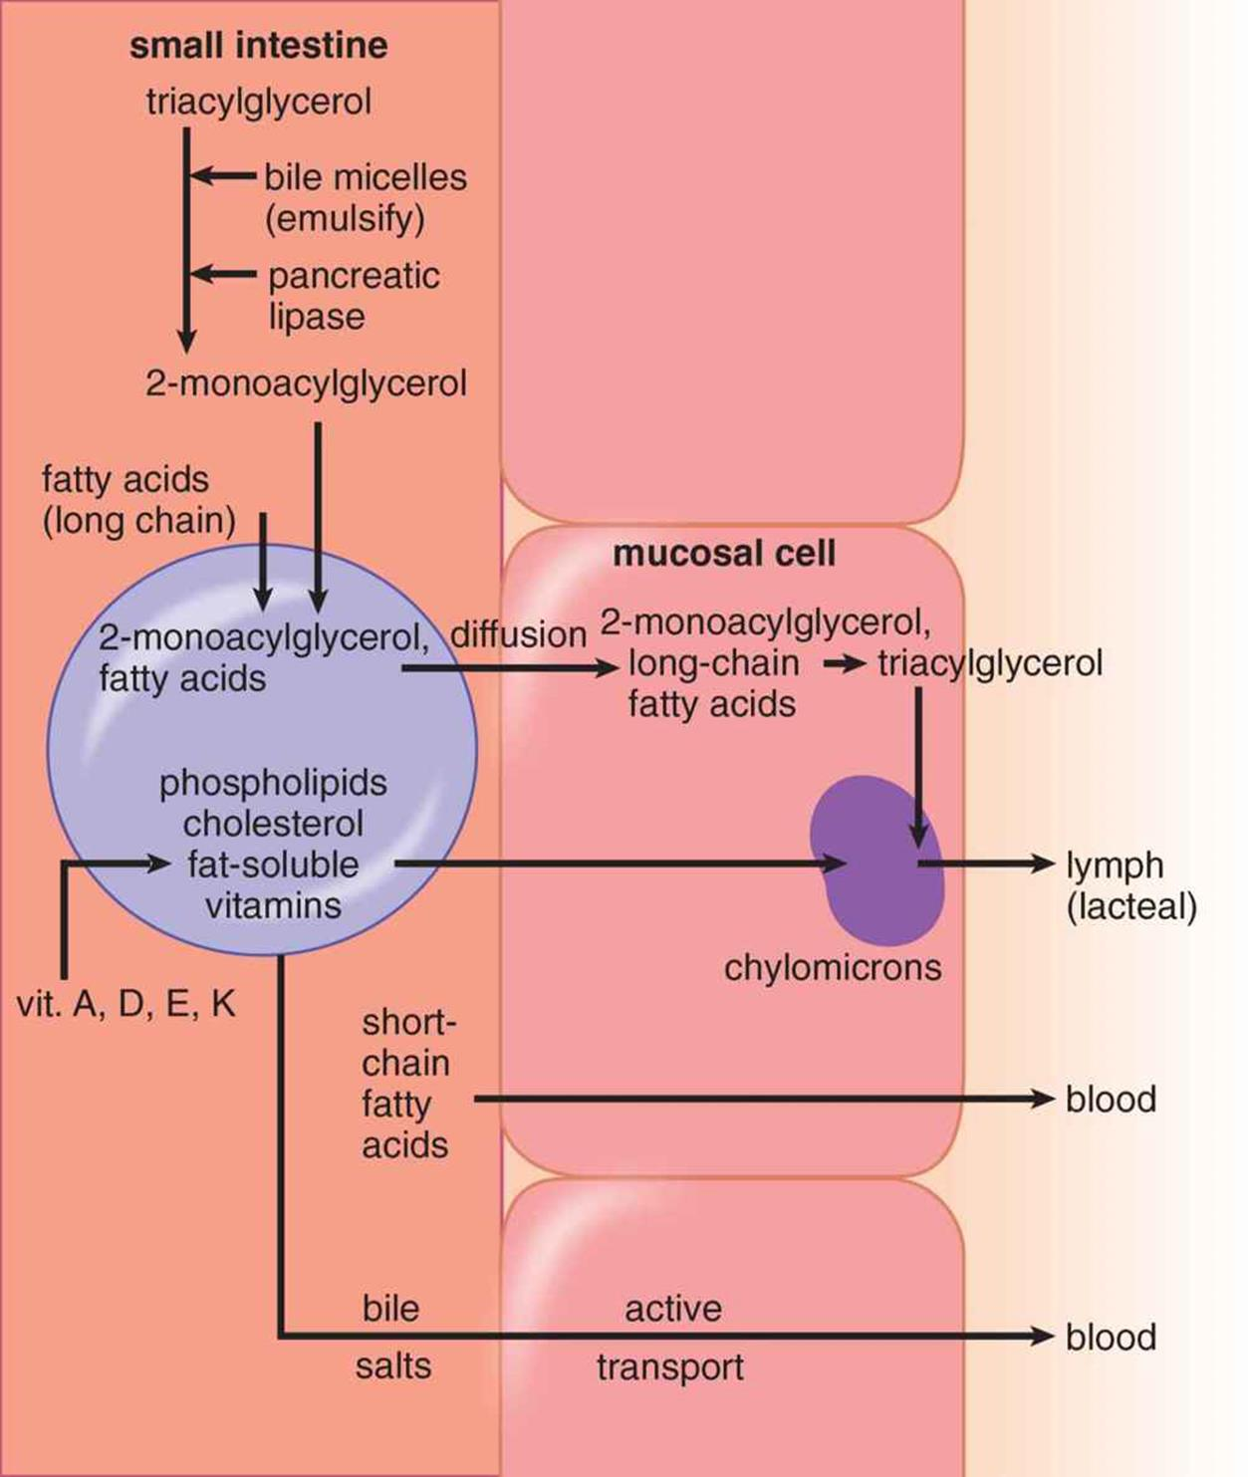

**11.2 Lipid Mobilization**

* Occurs when we need to tap of energy stores instead of food for fuel e.g. postabsorptive and prolonged fasting states
* Lipids are mobilized from:
  + Adipocytes by hormone-sensitive lipase
  + Lipoproteins by lipoprotein lipase

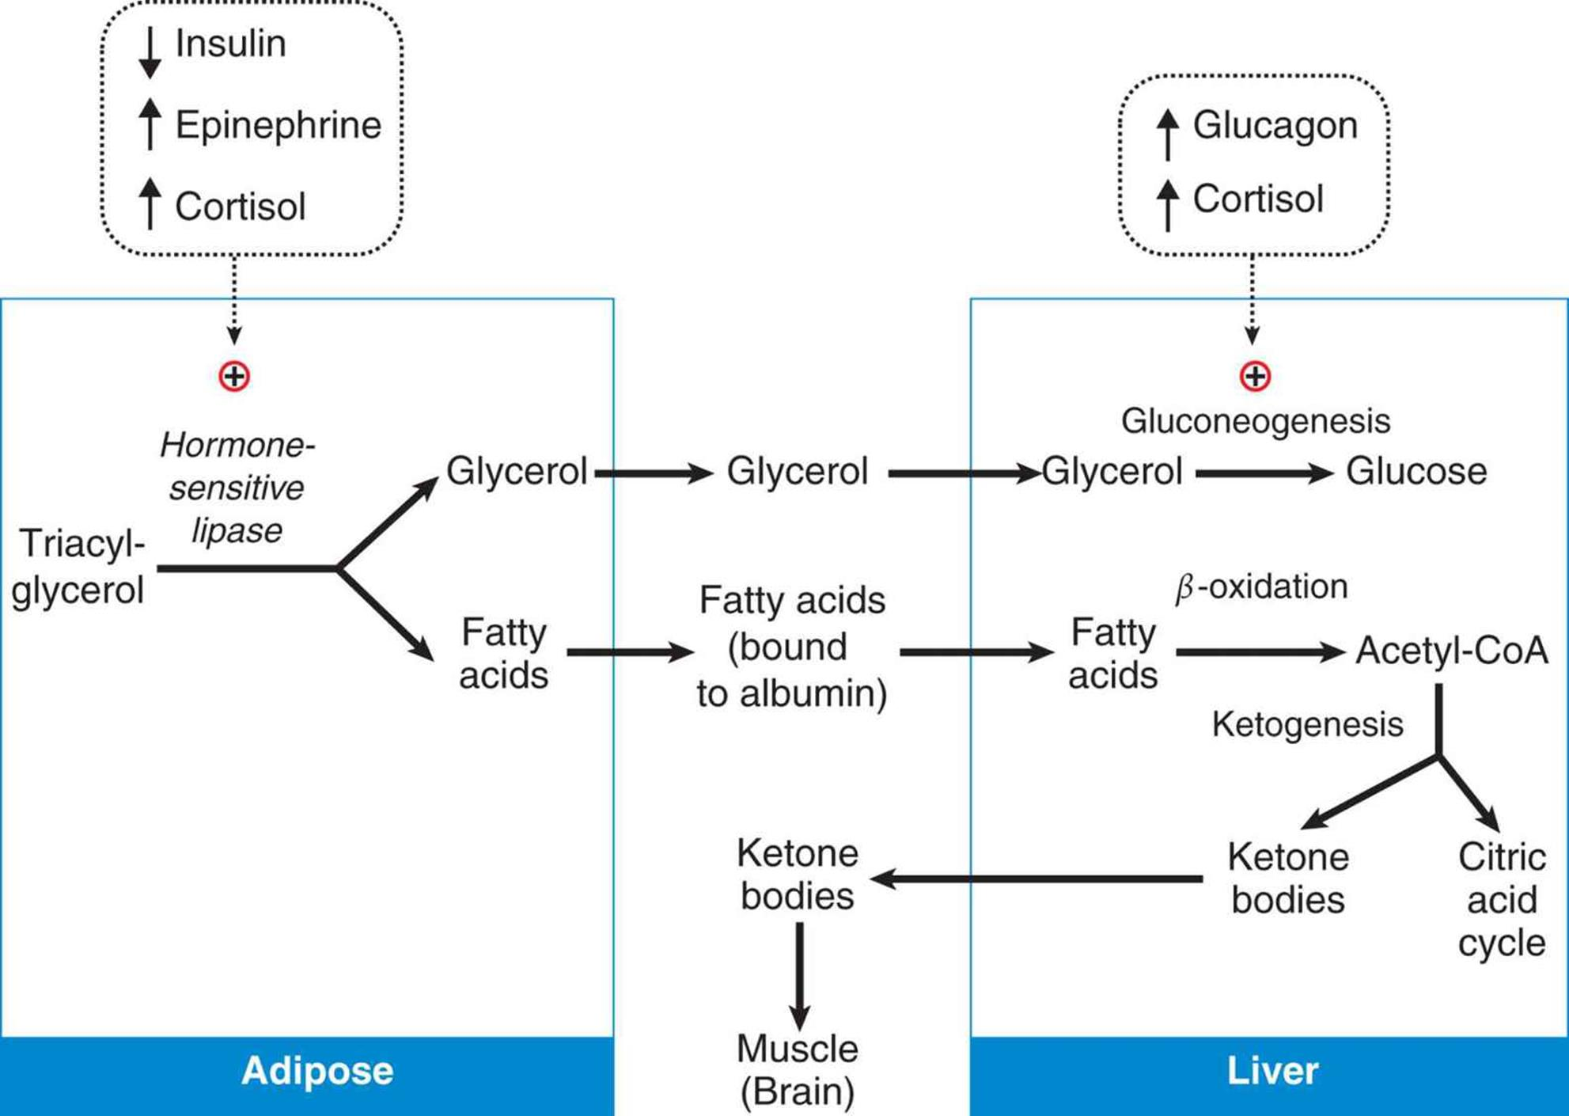

**11.3 Lipid Transport**

* Free fatty acids are transported through the blood in association with albumin (a carrier protein)
* Triacylglycerol and cholesterol are transported in the blood as **lipoproteins** (aggregates of apolipoproteins and lipids), named according to their density:
  + Chylomicrons < VLDL < IDL < LDL < HDL

Classes of Lipoproteins

* Chylomicrons and VLDL primarily carry triacylglycerols
* LDL and HDL primarily carry cholesterol
* IDL is intermediate
  + It is a transition state between VLDL and LDL, occurring as the primary lipid within the lipoprotein that changes from triacylglycerol to cholesterol

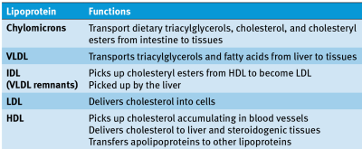

Apolipoproteins

* Control interactions between lipoproteins

**11.4 Cholesterol Metabolism**

* Plays a major role in the synthesis of cell membranes, steroid hormones, bile acids, and vitamin D
* The key enzyme in cholesterol biosynthesis is **HMG-CoA reductase**

Sources

1. Dietary sources
2. *De novo* synthesis in the liver

Specific Enzymes

1. LCAT
   1. Catalyzes the formation of cholesteryl esters for transport with HDL
2. CETP
   1. Catalyzes the transition of IDL to LDL by transferring cholesteryl esters from HDL

**11.5 Fatty Acids and Triacylglycerols**

Nomenclature

* Saturated fatty acids have no double bonds between carbons
* Unsaturated fatty acids have one or more double bonds

Synthesis

* Palmitic acid is the only fatty acid that humans can synthesized
* Produced in the cytoplasm from acetyl-CoA transported out of the mitochondria

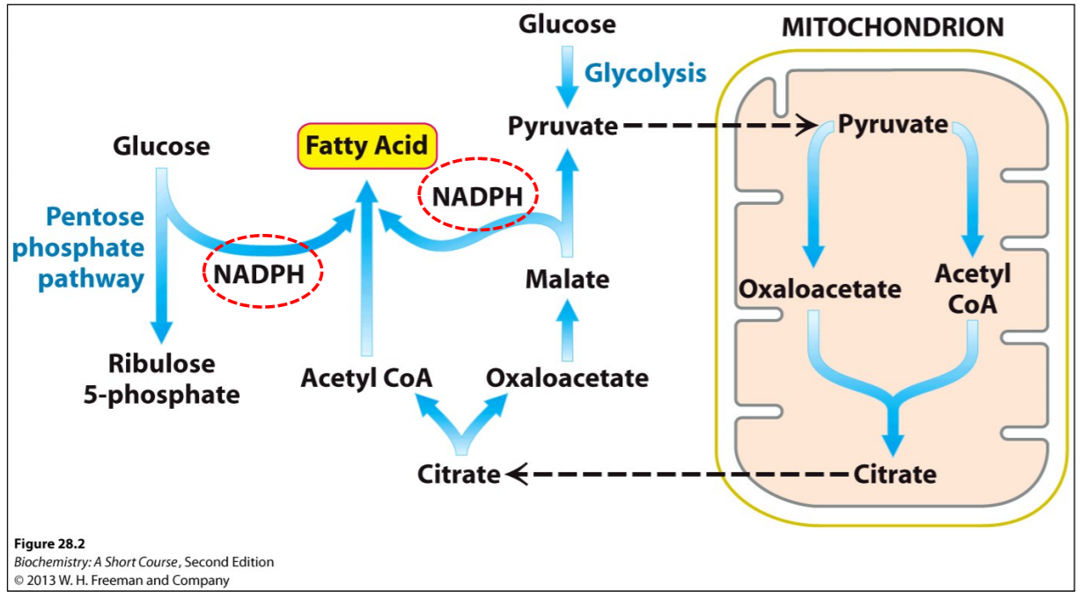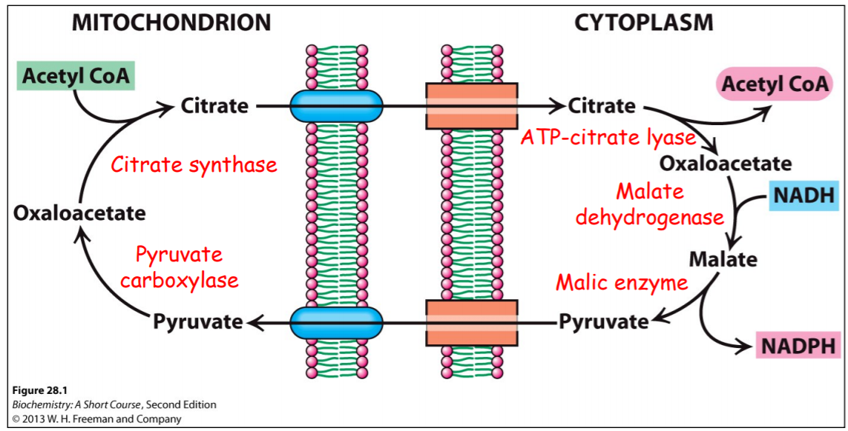

Oxidation

* **Occurs in the mitochondria** following transport by the carnitine shuttle
  + β-oxidation uses cycle of oxidation, hydration, oxidation, and cleavage
    - **Reverse of the process of fatty acid synthesis**
  + Branched and unsaturated fatty acids require special enzymes
  + Unsaturated fatty acids use an **isomerase** and an additional **reductase** during cleavage

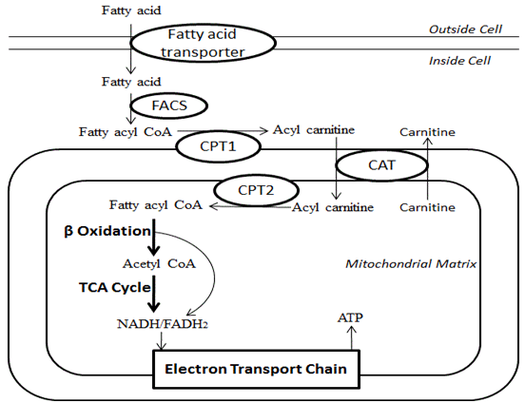

**11.6 Ketone Bodies**

* Fatty acid degradation results in large amounts of acetyl-CoA, which cannot enter the gluconeogenic pathway to produce glucose
* Only odd-numbered fatty acids can act as a source of carbon for gluconeogenesis; even then, only the final malonyl-CoA molecule can be used
* Energy is packaged into ketone bodies for consumption by the **brain** and **muscles**

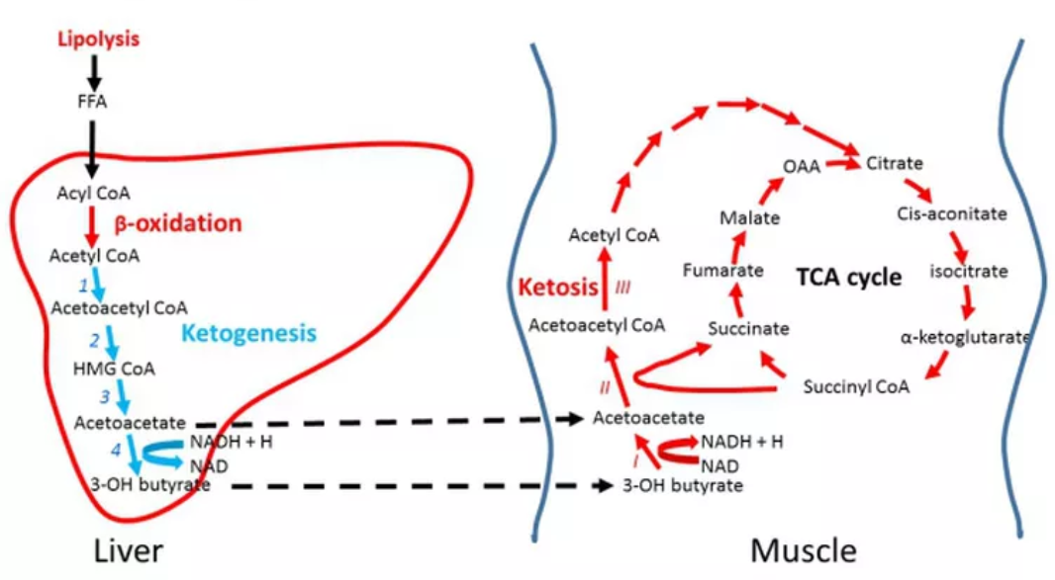

Ketogenesis

* Favoured by a prolonged fast and occurs in the liver
* Stimulated by **increasing concentrations of acetyl-CoA**

Ketolysis

* Regenerates acetyl-CoA for use as an energy source
* Does not occur in the liver
* Stimulated by **low-energy state in muscle and brain tissues**

**11.7 Protein Catabolism**

* Protein digestion occurs primarily in the small intestine
* Catabolism of cellular proteins occurs under conditions of **starvation**
* Eventual fate of components of amino acids:
  + Carbon skeletons
    - Used for energy, either through gluconeogenesis or ketone body formation
  + Amino groups
    - Fed into the urea cycle for excretion
  + Side chain
    - Depends on its chemistry